- $e^{\left(a1+a2+…+an\right)x}$
Coefficient of x^{k} is $\frac{{(a1+a2+…+an)}^{k}}{k!}$
- Linear Recurrence:
GF: A(x).
Recurrence: A(i) = C₀A_{i-1}+C₁A_{i-2}+…+C_{k-1}A_{i-k}
Let Q(x) = 1-C₀x-C₂x²-…-C_{k-1}x^{k-1}. We can show each k -order recurrence can be described by A(x) = P(x) / Q(x) such that
- Q(x) is of degree k, and contains the coefficients of the recurrence. Additionally, the constant term is 1 (or Q(0) = 1).
- P(x) is of degree < k.
The generating functions P(x) / Q(x) and P(x)R(x) / Q(x)R(x) generate the same sequence. If we let R(x) = Q(-x) then all odd terms of the denominator will be vanished.
Another way to look at it:
Let M(x) = x^{k}-C₀x^{k-1}-C₁x^{k-2}-…-C_{k-1}
Let m_{l}x^{l} + m_{l-1}x^{l-1} + m_{l-2}x_{l-2} + … + m₀ be any polynomial divisible by M(x). Then:
m_{l}​A_{l}​+m_{l−1}​A_{l−1}​+m_{l−2}​A_{l−2}​+⋯+m₀​=0

S(x) = s_{k−1}​x^{k−1}+s_{k−2}​x^{k−2}+⋯+s₁​x+s₀ = ​x^{N} % M(x).
Then A_{N}=A_{k-1}S_{k-1}+A_{k-2}S_{k-2}+…+A₁S₁+A₀S₀

A LR can be shown by the help of many different recurrences.
If A(n) = $\sum_{i=0}^{k-1}{A\left(n-b\left(i\right)\right)*c(i)}$ then,
x^{N} % M(x) = $\sum_{i=0}^{k-1}{x^{n-b\left(i\right)}*c(i)}$ % M(x)
- The generating function for the Catalan numbers is
$$\frac{1- \sqrt{1-4x}}{2x}$$
- ${(1+ax)}^{n}= \sum{\left({n \atop k}\right)a^{k}x^{k}}$
- $\frac{1}{1-ax}=\sum{a^{i}x^{i}}$
- $\frac{1}{{(1-ax)}^{n}}=\sum{\left({i+n-1 \atop n-1}\right)a^{i}x^{i}}$
- ${\left(\sum_{i=0}^{inf}{S_{i}x^{i}}\right)}^{2}=\sum_{i=0}^{inf}{S_{i}S_{n-i}x^{n}}$
- Fibonacci Numbers:
$$f\left[0\right]=0, f\left[1\right]=1, f\left[n\right]=f\left[n-1\right]+f\left[n-2\right]$$
$$\underset{→}{yields}G\left(x\right)=xG\left(x\right)+x^{2}G\left(x\right)+0+x$$
- Catalan numbers: 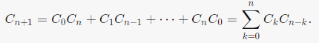
$\underset{→}{yields}G\left(x\right)=xG\left(x\right)+1$, [+1 is beacause C[0] = 1]
- $f\left[0\right]=K, f\left[n\right]=A*f\left[n-1\right]+B*\sum_{i=1}^{n-1}{f\left[i\right]*f\left[n-i\right]}$
$$\underset{→}{yields}G\left(x\right)=K+AxG\left(x\right)+Bx{G(x)}^{2}$$
- 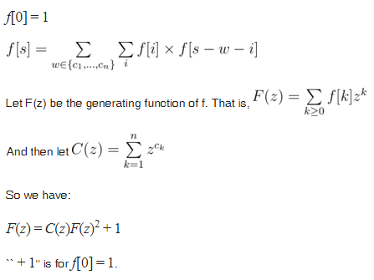
- 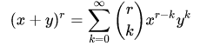
- Find
This is equivalent to the coefficient of Thus the solution is the coefficient of x^{N} of the above eqn, which on expanding binomially we get 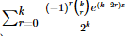 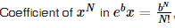 thus coefficient of x^{N} in the above eqn will be, multiplied by 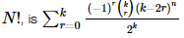
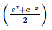
- 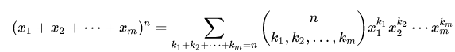
- $f\left[n\right]\left[k\right]=f\left[n-1\right]\left[k\right]+f\left[n\right]\left[k-1\right]+\left(n-1\right)*f\left[n-1\right]\left[k-1\right], f\left[0\right]\left[0\right]=1, f\left[0\right]\left[n\right]=f\left[n\right]\left[0\right]=0, f\left[n\right]\left[1\right]=n*(n+1)/2$
$$F\left(x\right)=\prod_{i=1}^{n}{(x+i)}, f\left[n\right]\left[k\right]= \sum_{i=1}^{k}{\left({k-1 \atop i-1}\right)F\left(x\right)[n-i]}$$

